**Production Incident Management**

**Team #26**

**Zackary Finer**

**Antoine Ngu**

**Dale Christian Seen**

**Project Overview**

Any software company will need to manage production incidents. On top of management of these production incidents, the corporation will also need to gather analytics on any production incidents that have occurred (such as what systems are usually effected, and what possible sources of these production incidents are) so they can correctly direct developers to resolve the source of these issues.

Our database management service will streamline the process of collecting, monitoring, and analyzing production incidents.

**System Environment**

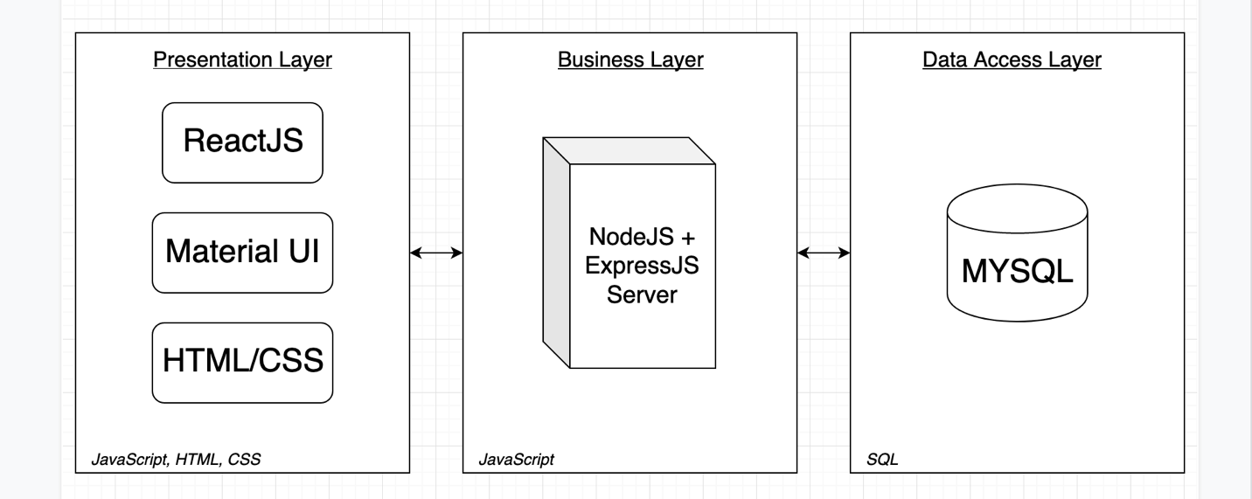

**Functional Requirements**

… TO-DO …

**Non-functional Issues:**

We will be using Facebook's React library to build the GUI of our application. React is a popular frontend framework among web developers because it makes the task of building an app's GUI much easier and simpler by breaking the various parts of a web page into encapsulated components. Knowing this, the team decided to use this technology so that the team can spend more time on the backend implementation and interactions with the database.

Along with React, the team will also use Google's Material UI framework to make our GUI more responsive to varying screen sizes and uniform in its overall styling. Using Material UI would also make our frontend much easier to implement and thus the team can spend more time on the backend and database.

For the security of our app and its users, we will be using various libraries for hashing and salting user credentials, Web tokens for keeping track of sessions and access control, and user authorization.